AWT and Swing

--------------------------

-->Awt is a basic set of controls, windows and dialog boxes that support a usable but limited graphical interface.

-->Awt translates its visual components into their corresponding platform specific equivalents.

-->The look and feel of components is defined by the platform not by Java. -->Since the awt components use native code resources, awt components are heavyweight.

-->Swing is a set of classes that provides more powerful and flexible GUI components than awt.

-->The look and feel of swing components is not platform specific.

-->swing components are called lightweight because they are entirely written java and do not map to platform specific look and feel.

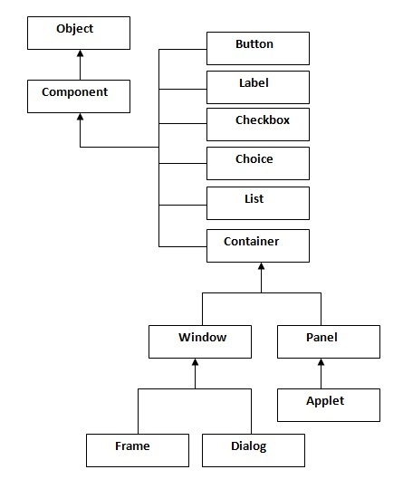  
Fig: AWT components Hierarchy

**TextField**

Container: The Container is a component in AWT that can contain other components like buttons, labels etc.

Window: The Window is a container that has no borders and menu bars. We must use Frame, Dialog for creating a window.

Panel: The Panel is a container that doesn’t contain title bar and menu bars. It is a super class of Applet.

Frame: The Frame is a window that contains title bar and can have menu bars.

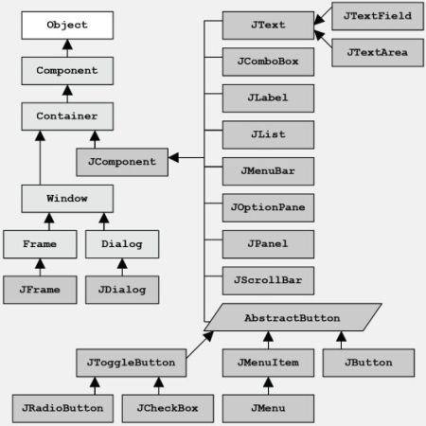

Fig: Swing components Hierarchy